Jonathan Hess

EE 185 Lab 1- Garden Light

How I think it works:

The Led is powered by the rechargeable battery. The battery lights the led when there is not enough voltage across the solar panel. When there is enough voltage on the solar panel the IC allows the current to flow from the solar panel into the battery reducing the potential to near 0 turning off the Led.

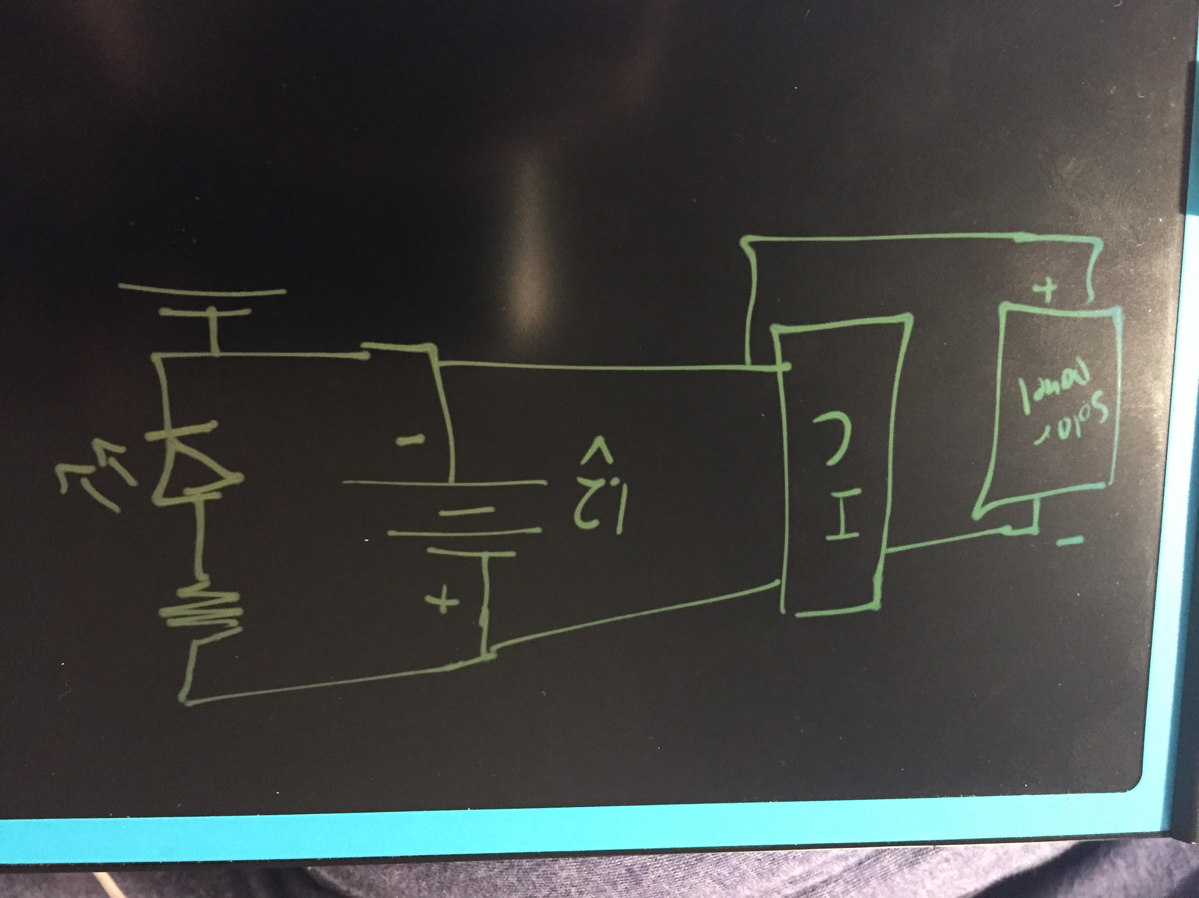

Basic diagram

How I found out how it works:

I tested the battery voltage to be 1.2, similar to what is outputted from a solar panel. I Then tested the potential when there was light on the solar panel (led was off) and it was 0 or near zero. I then looked up what the IC was (BD5252FVE). It turned out to be a voltage detector which made sense with how it was acting as a switch where the LED was on or off with no noticeable dimming or in between the two states.